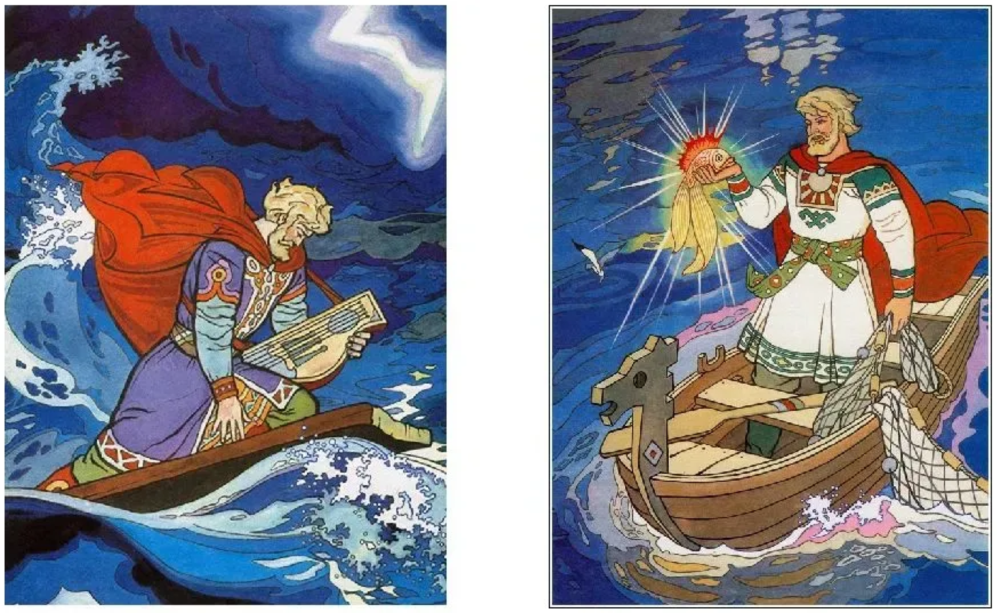***Опера «Садко»***

***Н.А. Римский – Корсаков***



_____________________________________________



_____________________________________________





__________________________________________



__________________________________________

