***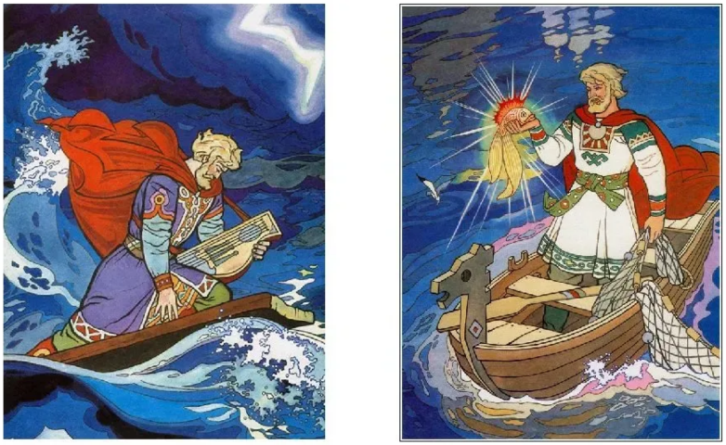****** Опера***

***«Садко»***

***Н.А. Римский – Корсаков***



_____________________________________________



_____________________________________________________________









